Q2: What were some reasons why people in the U.S.S.R. supported Stalin?
(What were Stalin’s supporters thinking?)
Between 1928 and 1939 Joseph Stalin transformed the Soviet Union into a modern industrial power. He did this by using his enormous power as a dictator to force rapid industrialization, while also destroying private land ownership and collectivizing agriculture. The collectivization policy led to famine in rural areas, which killed millions. Stalin also used the secret police and the “gulag” system of forced labor camps to eliminate any opposition to his rule. One man could not possibly have done so much - Stalin had many enthusiastic supporters. What were they thinking?
To help you to answer that question, study the documents provided, and answer the questions for each set. There are additional questions to answer once you have studied all ten documents.

Documents 1 – 3
I. Sources and Context
-Identify and date these sources:
-Who is the author, and what is his position or title?
- What has happened in our unit story at the time this source was created?
II. Summary
-What do these sources say?

III. Interpretation
-What reason(s) do these sources suggest that people might have supported Stalin? Explain your
thinking with specific reference to the sources.

Documents 4 – 6
I. Sources and Context
-Describe these sources; what are they?
-When do you think they were created?
-What questions do you have about the source of the data for these sources?
- What part(s) of our unit story do these sources tell you about?

II. Summary
-What do these sources say?

III. Interpretation
-What reason(s) do these sources suggest that people might have supported Stalin? Explain your
thinking with specific reference to the sources.

Documents 7 - 10
I. Sources and Context
-Identify and date these sources:
-Who created these sources?
- What part(s) of our unit story do these sources tell you about?
II. Summary
-What do these sources say?

III. Interpretation
-What reason(s) do these sources suggest that people might have supported Stalin? Explain your
thinking with specific reference to the sources.

QUESTIONS FOR REFLECTION & ANALYSIS
1. Explain why was each set of sources grouped together. What do they have in common?

2. What do the sources suggest about what people in the U.S.S.R. knew about what was happening during the 1920s and 1930s?

3. Write an outline to answer Question Two for Stalin’s supporters. For each section of the outline write a topic sentence that says why some people might have supported Stalin. Underneath each sentence, note which sources support your interpretation, and explain why they do.

Document 1: Stalin launched his first Five-Year Plan in 1928 by setting up a planned (or “command”) economy, in which the state would control all business and industry in order to increase Soviet industrialization very fast. Stalin set very high “production targets” for each industry, and managers were punished if they did not meet them. In this excerpt from a 1928 speech, Stalin explains why he thinks this is necessary.
To slow down would mean falling behind. And those who fall behind are beaten. But we do not want to be beaten! One feature of the old Russia was the continual beatings she suffered for falling behind, for his backwardness...
So you want our Socialist fatherland to be beaten? ...If you don't want this, you must end our backwardness. You must develop a real Bolshevik tempo [speed] in building our Socialist economy. There is no other road.
We lag behind the advanced countries by fifty to a hundred years. We must make good this distance in ten years. Either we do it, or we shall be crushed.

Document 2: In this excerpt from a 1929 speech delivered by Stalin, he explains his collectivization policy for agriculture and the need to eliminate the “kulaks” (wealthy farmers), who farmed land that they owned as private property.
Can we advance our socialized industry at an accelerated rate as long as we have an agricultural base, such as is provided by small-peasant farming, which is incapable of expanded reproduction, and which, in addition, is the predominant force in our national economy? No, we cannot. …The solution lies in enlarging the agricultural units…and in changing the agricultural base of our national economy. But how are the agricultural units to be enlarged?
There are two ways of doing this. There is the capitalist way, which is to enlarge the agricultural units by introducing capitalism in agriculture - a way which leads to the impoverishment of the peasantry… We reject this way as incompatible with the Soviet economic system.
There is a second way: the Socialist way, which is to set up collective farms and state farms which leads to the joining together of the small peasant farms into large collective farms, technically and scientifically equipped, and capable of developing further, for such agricultural enterprises can achieve expanded reproduction….
What does this mean? It means that we have passed from the policy of restricting the exploiting proclivities of the kulaks to the policy of eliminating the kulaks as a class. This means that we have made, and are still making, one of the decisive turns in our whole policy. …Now we are able to carry on a determined offensive against the kulaks, to break their resistance, to eliminate them as a class and substitute for their output the output of the collective farms and state farms.

Document 3: This chart shows the targets of Stalin's fist Five-Year Plan in millions of kilowatt hours (electricity) or millions of tons (all other goods), and the production levels at the start of the plan in 1928.
Industry | 1927-1928 | Target for 1933
Electricity | 5.05 | 17.0
Coal | 35.4 | 68.0
Oil | 11.7 | 19.0
Iron | 3.3 | 8.0
Steel | 4.0 | 8.3

Document 4: This chart shows the increase in Soviet industrial production under the first two Five-Year Plans.
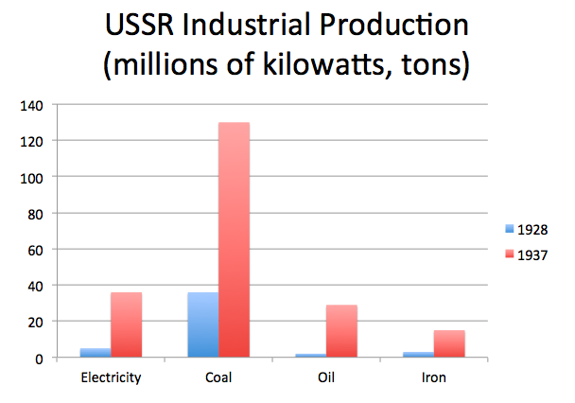

Documents 5 & 6: The following illustrations show the changes in Soviet agricultural production during the first two Five-Year Plans.
(The original livestock graph was in color. “Sheep and goats” are the line that starts at 150 million, “cattle” are the line that starts at 70, “horses” are the line that starts just under 40, and hogs are the line that starts at 20. For the second graph, a “centner” is a unit of measure that was sometimes used in Eastern Europe; it is equivalent to about 110 pounds.)
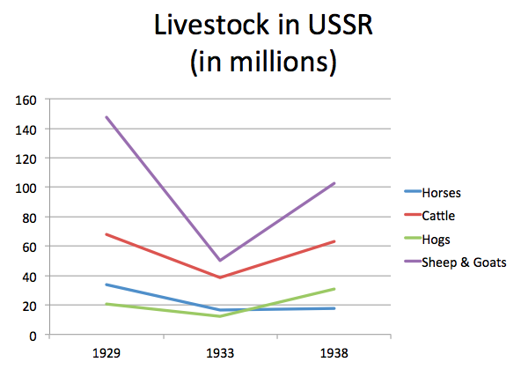
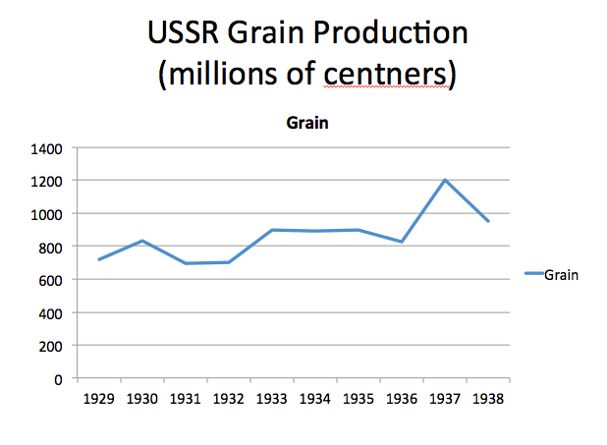

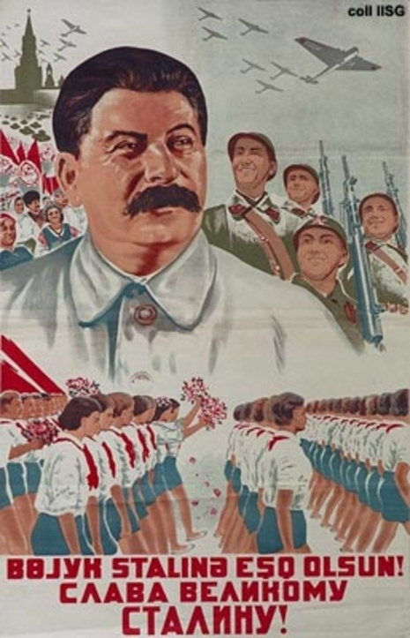
Documents 7 & 8: The poster on the left (mid-1930s) promotes mechanization of agriculture on large collective farms. The one on the right (1938) reads “Long Live the Great Stalin.” Posters like these were displayed in public spaces all around the U.S.S.R. during Stalin’s time.
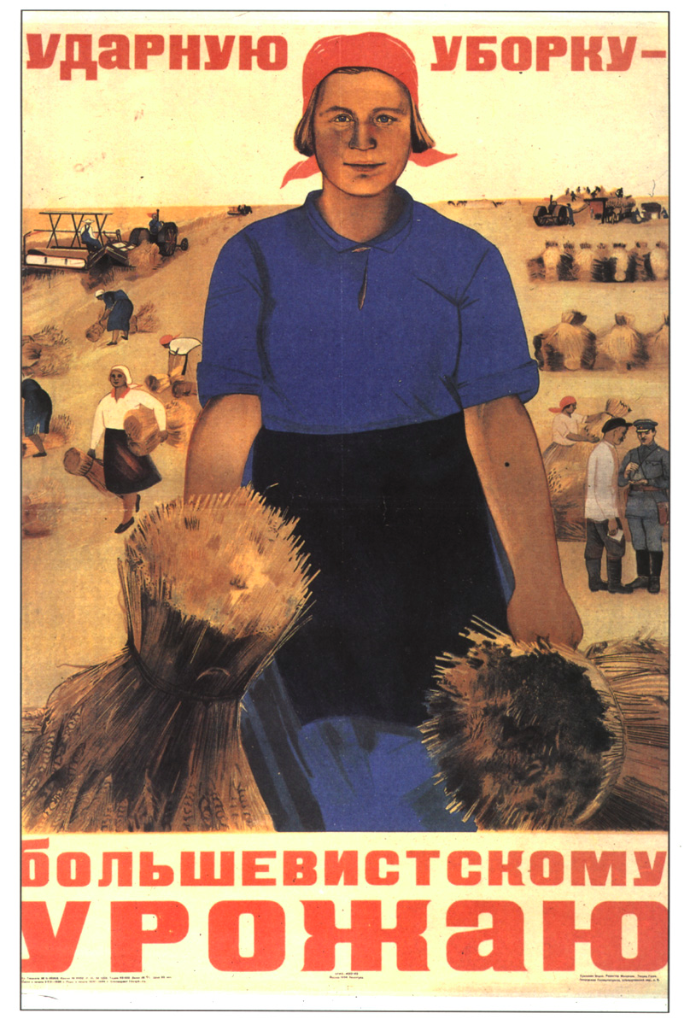

Document 9: This excerpt from The Land of the Soviets, a school textbook published in the U.S.S.R. in the early 1940s, describes the results of the Five-Year Plans.
The fulfillment of the first and second Five-Year Plans strengthened the Soviet Union’s economic position and turned it into a powerful industrial state. . . . In 1937 the industrial output of the USSR was 5.8 times larger than in 1913. The rate of industrial growth in the USSR considerably exceeded that of the capitalist countries. By 1937 the Soviet Union was the first country in Europe and the second in the world in the volume of industrial production. . . . Socialist industrialization was accompanied by the rapid growth of the working class, and made it possible to liquidate unemployment. In 1940 there were 9,971,000 industrial workers, which was nearly three times more than in 1928. The working class was also changing: its efficiency, technical and cultural levels were growing rapidly.
Document 10: This excerpt from The Land of Soviets, a school textbook published in the U.S.S.R. in the early 1940s, describes the campaign against the Kulaks.
The radical step forward by the majority of the peasantry towards a collective way of life was taking place against the backdrop of a bitter struggle between Soviet power and the kulaks. The [kulaks] stooped to all possible means to wreck the collectivization campaign. They murdered collective farm activists and Party and government officials sent to the villages to help the peasants; they set fire to collective farm buildings; they poisoned the cattle and destroyed farm machinery. . . . The Soviets had the right to banish them from their villages. . . . The exploiter class—the rural bourgeoisie—was finally abolished.

